**Kaleb Alstott**

**Lab 4**

**10/21/2024**

**Set-up**

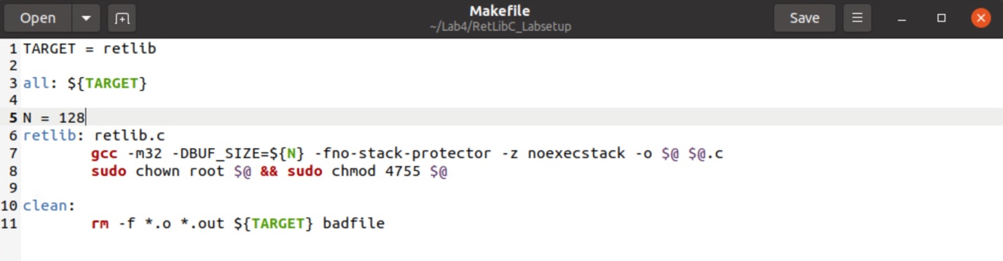

This is the setup step, in this step we had to make sure to modify the values of "N" in the *Makefile:* The value you use for "N" will depend on the first letter of your last name. Use the appropriate value of N from the list below:

* N = 128 for students whose last names start with A - K

**Task 1 Finding out the Addresses of libc Functions**

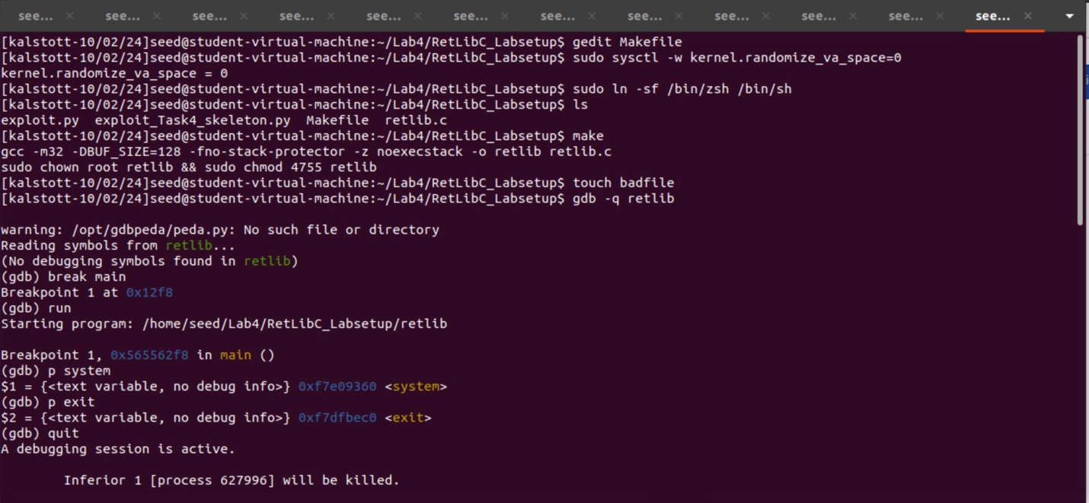

In this step we were tasked with finding out the address of libc functions. To start we needed to edit our Makefile to ensure that our N variable is the correct value correlating to our last name. In my case since my last name is Alstott my N value is 128. After so, we need to make sure that our countermeasure of address space randomization was turned off. This value is set to 0 meaning no randomization of address space. The next commanded it to ensure that the countermeasure in /bin/dash is disabled to due to how /bin/dash will drop the Set-UID  
privilege before executing our command. We disabled this protection by linking /bin/sh to another shell, in our case /bin/zsh, that does not have the countermeasure. After the countermeasures are turned off, we are good to run our make command which will turn off our stack guard protection as well as make our retlib program a Set-UID program.

After creating our empty file, badfile, with touch we are now able to start debugging the retlib program in order to find the key memory addresses of system() and exit(). These memory addresses will be used in our attack to one open the root shell and run shell commands as well as terminating the program when done. Now in the debugger we set a break point at main so when we use the run command we hit the breakpoint at main allowing for us to print the memory addresses of both system() and exit().

Once we have successfully recorded our memory address for both system() and exit() stated above and below in the screenshot, we can move on to the next step.

**Task 2 Putting the shell string in the memory**



**Previously where we left off from task 1**

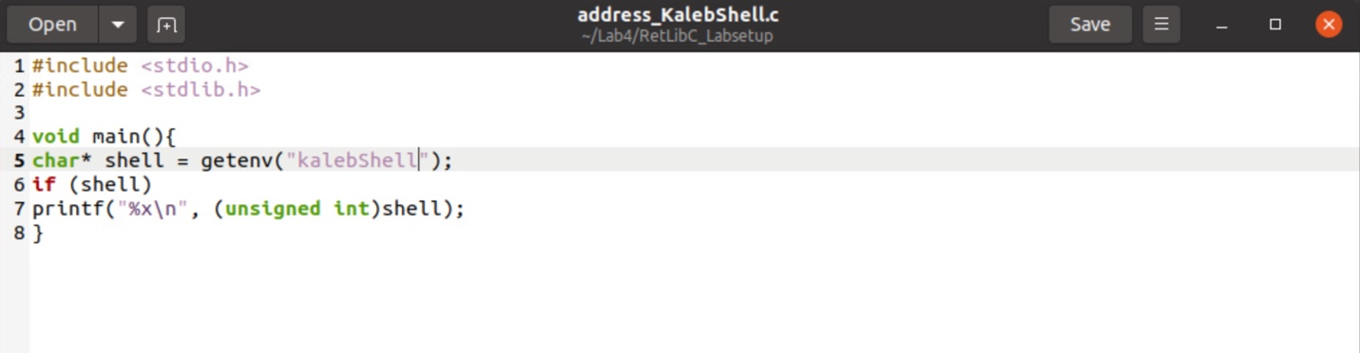

C file and code used to record the location of this variable in memory. The getenv("kalebShell") retrieves the value of the kalebShell environment variable in our case the "/bin/sh" string. When kalebShell is set it should print out the memory address where "/bin/sh" is stored.

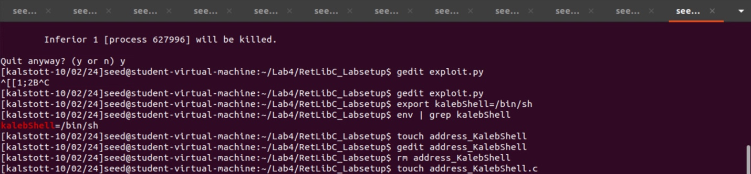

The goal here is to store the string "/bin/sh" in memory and know its exact memory address. Our method of doing so is by using an environment variable to set the memory address of /bin/sh. By using the export command, we are able to set my variable “kalebShell” to the /bin/sh string. We use the env | grep kalebShell command to confirm that our environment variable is set to the /bin/sh string. The following commands of gedit are used to create the C file and the code that is pictured above. I had a couple of issues as you can see above and below with me first forgetting the .c file and then had a code error.

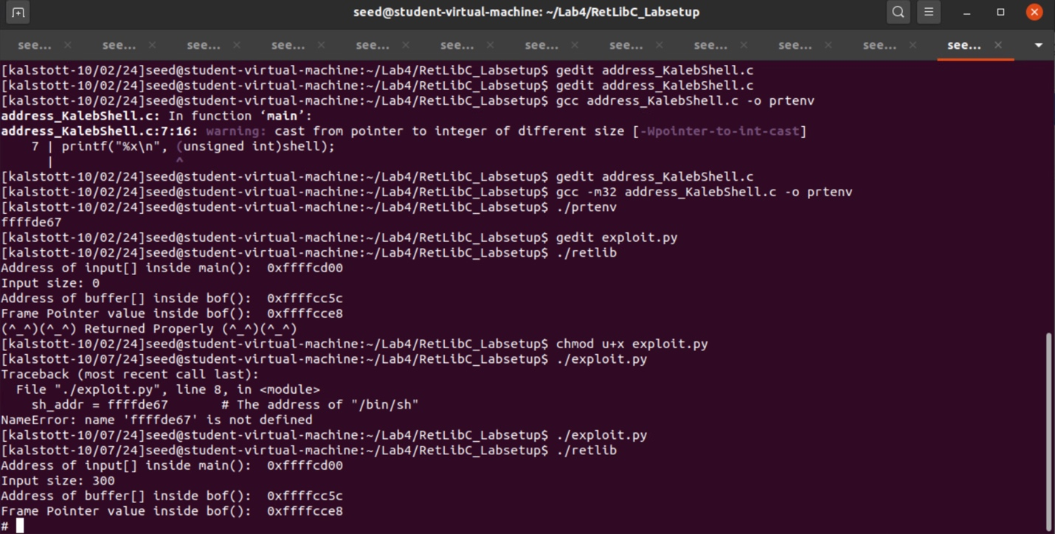

Once the C file was created and code was correctly implemented, we then ran the gcc command to compile the code with a 32 bit system using the flag -m32 and renamed our compiled file to prtenv. Running the prtenv command we can see the memory address given is the memory address for /bin/sh.

Note: It is important to note here that the length of the program name does make a difference. That’s why we choose 6 characters for the program name prtenv to match the length  
of retlib. The reason being is that if our program name is longer or shorter than the match length of retlib our env variable will shift memory addresses.

**Task 3 Launching the attack**



After finding our memory address for /bin/sh by using our code and env variable we used the gedit command modify our exploit.py file in which has our memory addresses that we needed to record in it. We took our exit() and system() address that we had recorded earlier and plugged them into our variables needing the memory address as well as our /bin/sh memory address to the correct variable.

Once our memory addresses are recorded correctly we move on to the values of x,y,z. Using the diagram below we can visualize where we are getting these values from. It was important to use a refrence or drawing for this step due to having to think about the memory layout in the perspective of args -> return address -> PFP -> local vars. Using this knowledge, we had to subtract the memory address of our $ebp (frame pointer) from our &buffer (buffer) in order to figure out where our offset is. This offset is needed to overwrite the return address, allowing for us to place the address of system() in that position. In which system should be the memory address of /bin/sh invoking the shell for us to use. We can see in the above screenshot that by running our retlib program we are able to record the values used for both the buffer and frame pointer value that we had to subtract. The value that we were given was 140. Using this value and the diagram provided we were able to correctly increment the offset to the needed values that were recorded for x, y, and z. These values are x= 152, y= 144, and z= 148.

As you can see in the screenshot above, we had to ensure that the our exploit.py program had execution permission first before running the attack. Using the commands to run ./exploit.py as well as ./retlib we see that our attack was successful allowing us to gain root shell access as well as confirming that our attack worked.

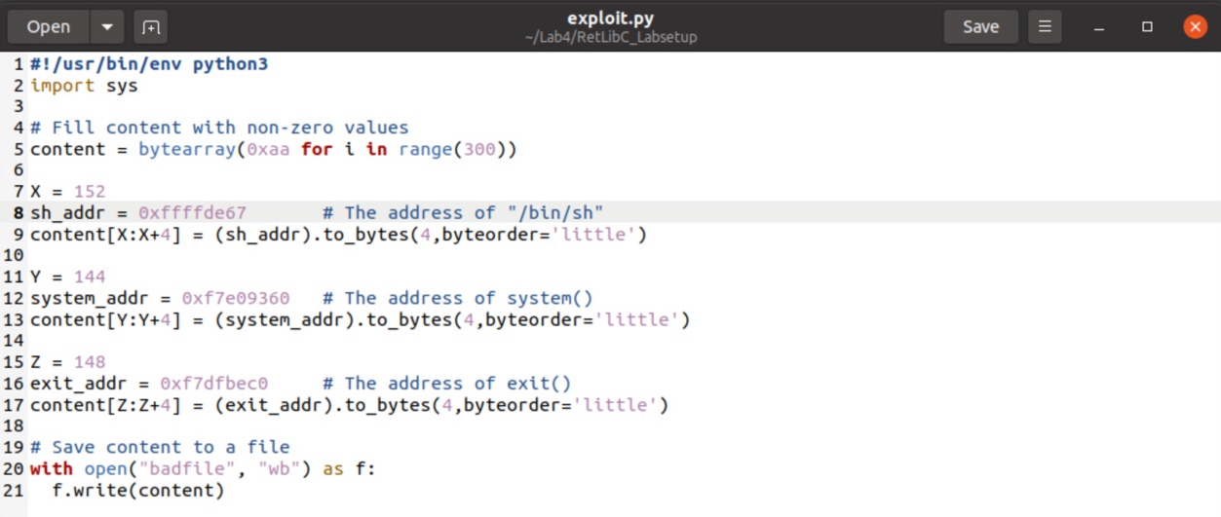

Code used for exploit.py with correct memory address values for variables as well as correct values using initial offset of 140.



Diagram drawn in class further explaining the use of args -> return address -> PFP -> local vars and the values used for this.

**Attack variation 1:**

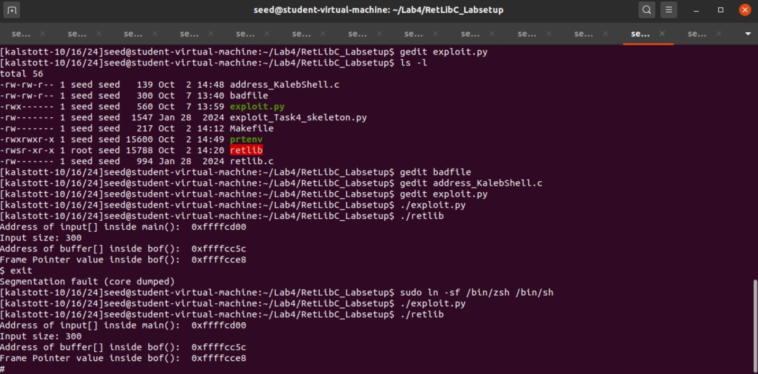

In this attack variation we were removing the exit() function to see if it is necessary to have for us. After modifying the exploit.py file correctly (I forgot what file we were using and had a brain fart here), we were able to run the command. I realized with this time the attack did not give us root and I forgot to turn off the countermeasure. After turning off the countermeasure and linking our /bin/sh to /bin/zsh we ran the command giving us root shell meaning a successful attack. But when we decided to exit instead of a clean exit, we encountered the “Segmentation fault (core dumped)” due to our not so clean exit. The program might crash like ours did when exiting due to the no clean exit.

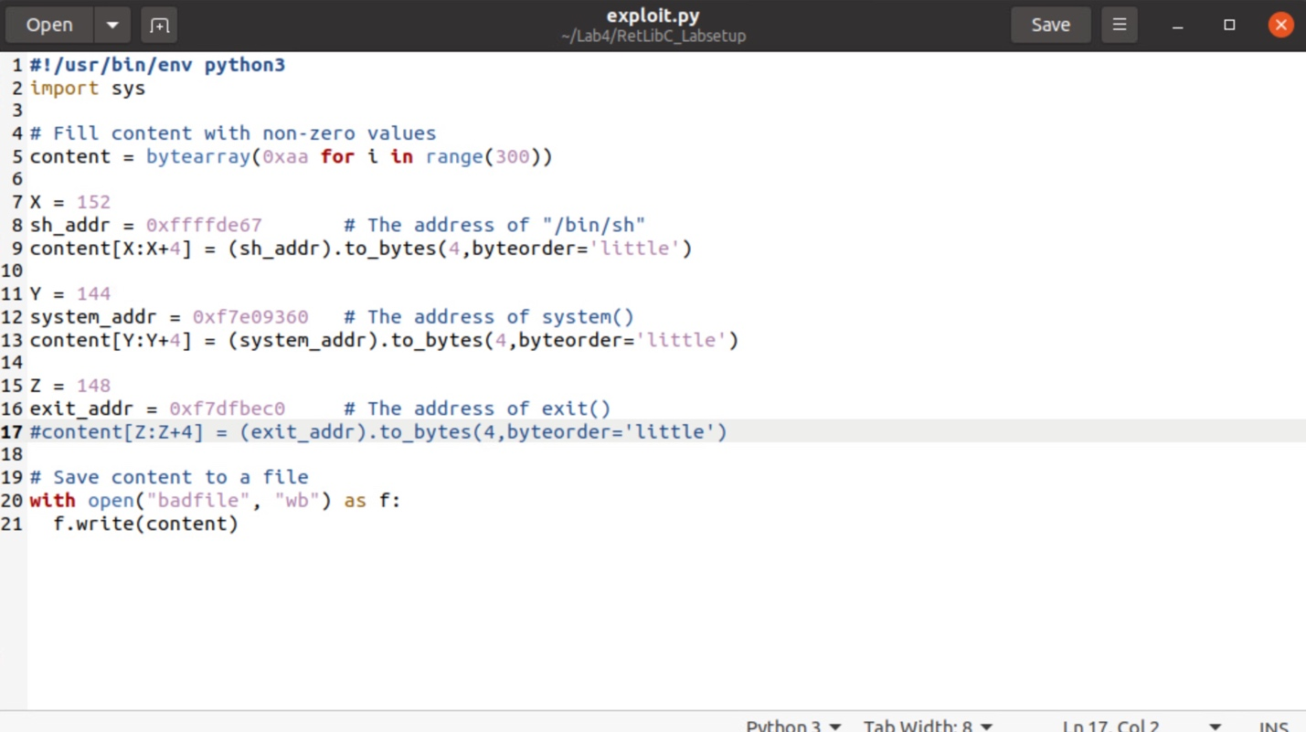

Code with the commented-out exit address like described in this variation of the attack.

**Attack variation 2:**

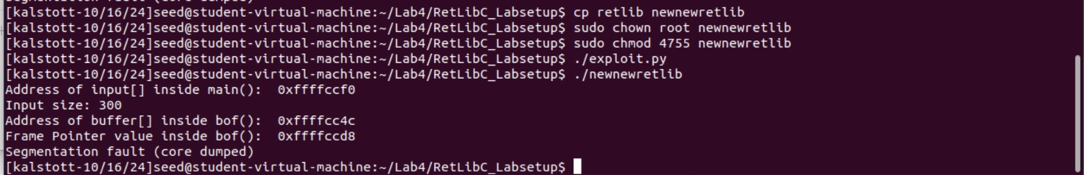

In this attack variation we were tasked with changing the file name of retlib to a different  
name, making sure that the length of the new file name is different. We started off by making a copy of retlib and naming it something different in length for the file name, mine being the newnewretlib. After renaming the file we run the same commands as we did to conduct the attack. As we can see here the attack was unsuccessful, this is due to the new length of the file name. Changing the file name length affects the memory layout and the environment variables may be stored in different locations like we are seeing in this attack variation.

**Task 4 Defeat Shell’s countermeasure:**

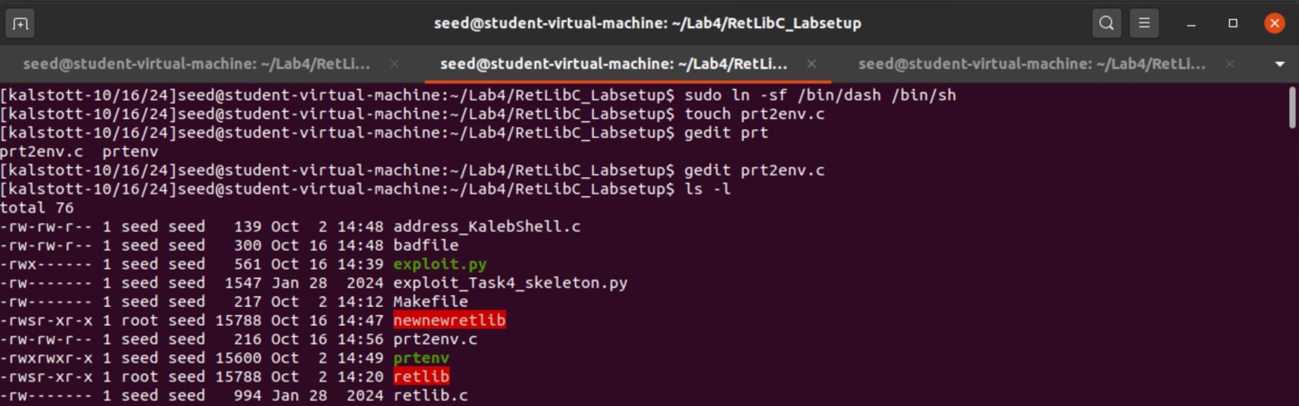

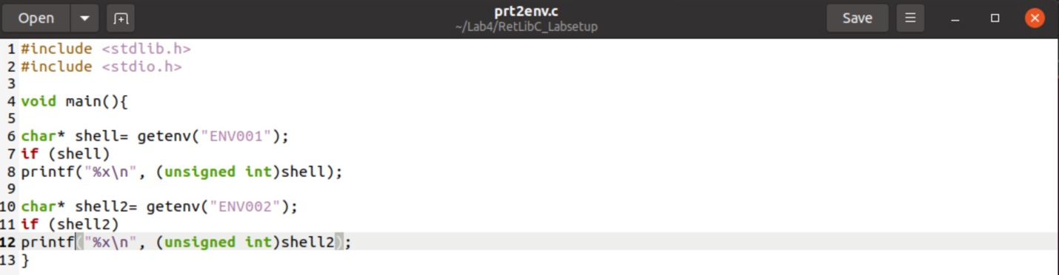

In this task we are challenged with working around a countermeasure in shells like dash and bash which drop privileges in Set-UID processes. To defeat this countermeasure, we must first make sure that the countermeasure is on and that our symbolic link is linked to /bin/dash. We do so with the first command in the screenshot.

Just like in our first attack we need some type of C file and code used to record the location of now two variables in memory. We do so by touching and creating our prt2env.c file. The getenv("ENV001") retrieves the value of the ENV001 environment variable in our case the "/bin/sh" string. The getenv("ENV002") retrieves the value of the ENV002 environment variable in our case the "-p" string.

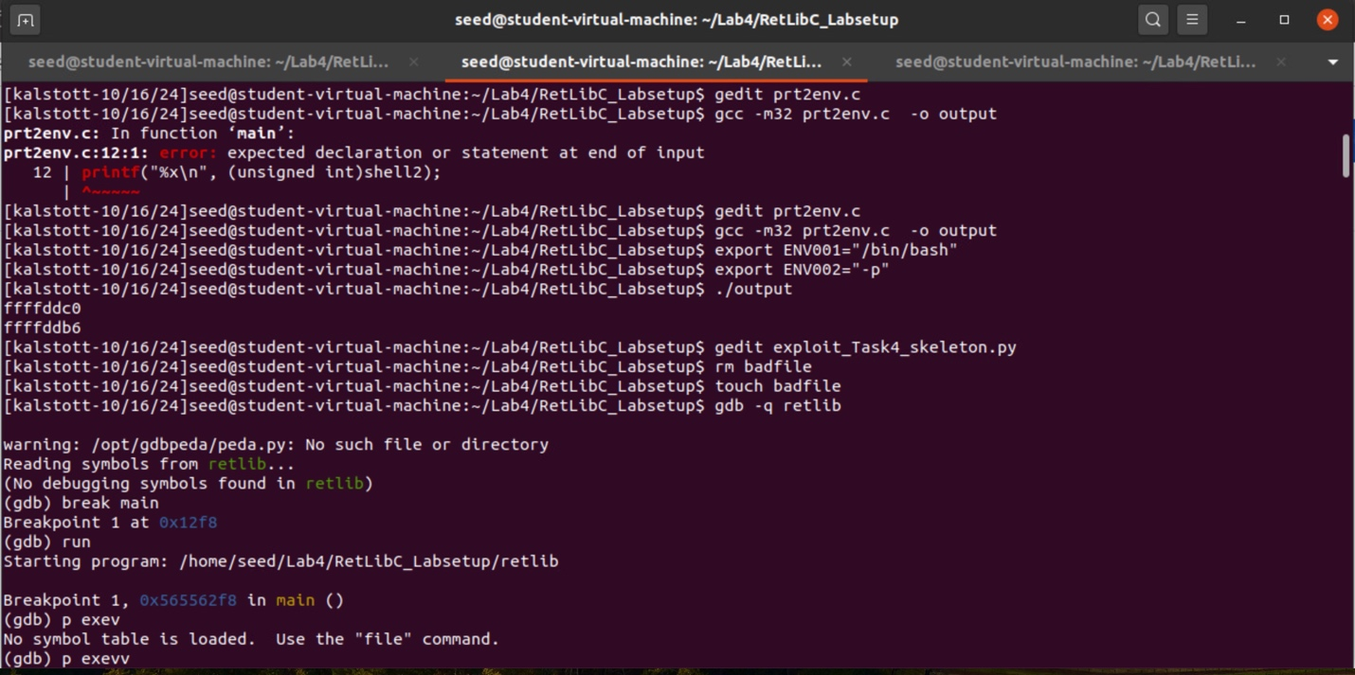

The goal here is to store the string "/bin/sh" in memory and know its exact memory address same as for our -p string. Our method of doing so is by using an environment variable to set the memory address of /bin/sh same with -p with our other env variable.

Once the C file was created and code was correctly implemented, we then ran the gcc command to compile the code with a 32 bit system using the flag -m32 and renamed our compiled file to output. MAKE SURE THAT THIS FILE IS THE SAME LENGTH, this si described earlier due to how it will affect your env variable memory address.

By using the export command, we can set my variable “ENV001” to the /bin/sh string as well as “ENV002” to the -p string. After setting our env variables we follow this by running our renamed program. The memory addresses that are printed out here, are the first one being the /bin/sh memory addresses as well as our second address being the memory addresses for -p.

We are going to use these later in this attack and are going to be recorded in our exploit_Task4_skeleton.py program where the code stats to put the memory addresses of both into the correct variables. We do so immediately after with the gedit command recoding str_bash = 0xffffddc0 (memory address for /bin/sh) and str_minus_p = 0xffffddb6 (memory address for -p). After these memory addresses were recorded in our file, we made sure that we had created a new blank badfile for this attack.

We are still missing 3 memory addresses for our program though. Similar to what we did in the first attack to find these values you must debug our vulnerable program retlib. Like so in the first attack, we reiterate creating a break point in main in which we follow this by the run command. We hit the breakpoint at main allowing for us to print the memory addresses of both execv() and exit().

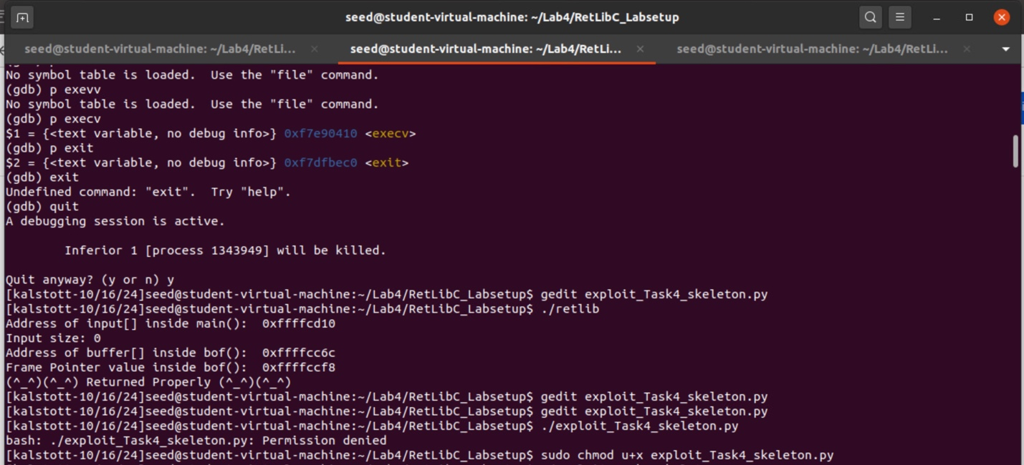

Once we have successfully recorded our memory address for both execv() and exit() in the screenshot, we can move on to the next step. We will need these in one second to finish filling out our 5 memory addresses needed for the code and this attack.

We have one remaining memory address left, main_buffer. Just like in our first attack we need to run the ./retlib program to record the values of the buffer main as well as buffer and ebp. The buffer memory address of the inside main() will be needed for our last memory address. As well as in this step we will need to record the difference of ebp-buffer (both using the memory address for inside bof()) to figure out the values of w, x, y, z later. For reference our memory address for buffer_main is 0xffffcd10.

We have now recorded all the memory addresses correctly in our code stated in the screenshot below, the next step before running the code is to finish filling in the values of w. x. y. and z.

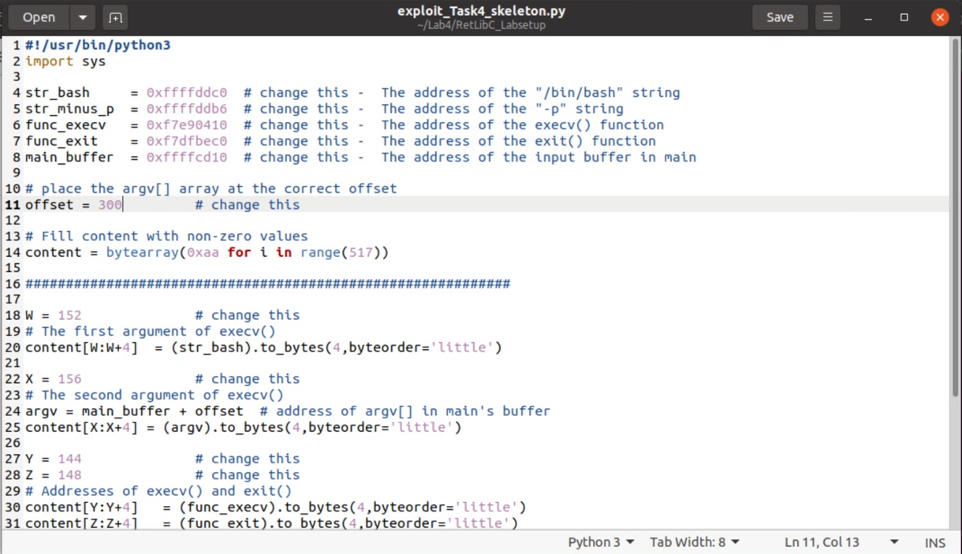

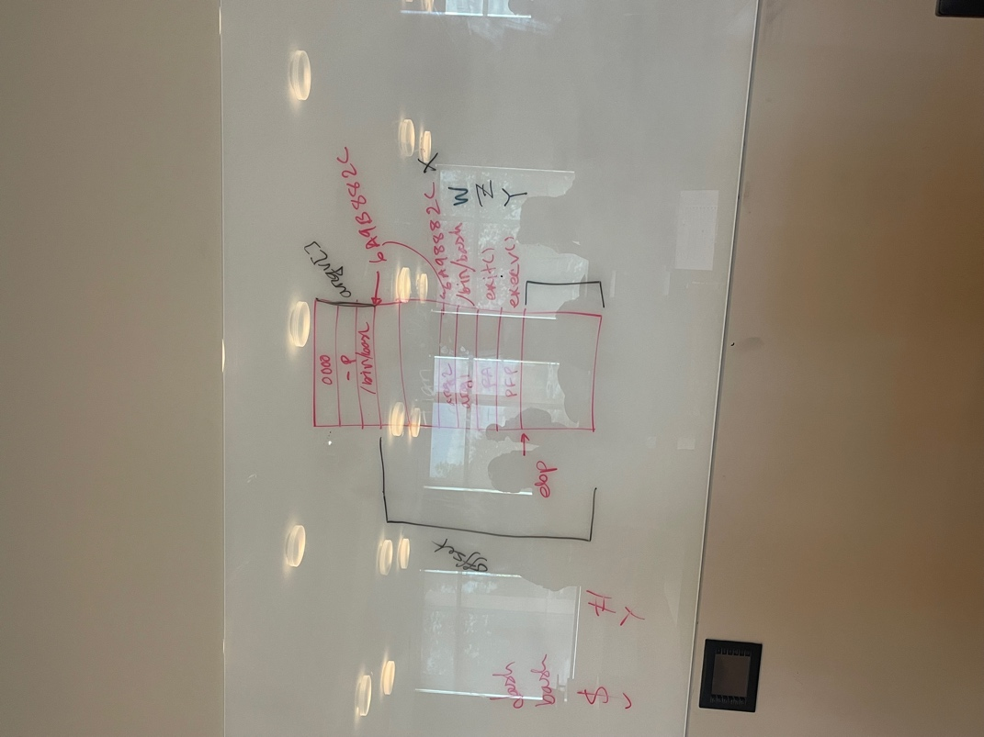

Using this diagram I am going to explain how we were able to find the values of w, x, y, and z for our program. Similar to our first attack we need to understand the memory layout of args -> return address -> PFP -> local vars and the values used for this. By understanding the stack layout as well as looking at the code that was constructed we can conclude that w = is the first argument of execve(), x = the second argument of execve(), y = memory address of execv(), and lastly z = our memory address for exit(). For reference here the execv() function looks like this int execv(const char *pathname, char *const argv[]); .

We figured this out by understanding that our exit is our return address in stack layout, our execve() is our PFP, followed by understanding that arg1 is after arg2 limiting us down to our arg1 being w and our arg2 being x. After we sketched this out, we were able to start constructing values for these variables.

Taking our understanding of where we need to be at in our stack memory we know that we have to find the offset of $ebp - &buffer in order to start recording the correct value for w, x, y, and z.

ebp - buffer will give us the number of bytes between the start of the buffer and the pointer.

Once we know this value which in our case it was 140, we could start to calculate where specific things like the return address (Y), execv()'s arguments (W and X), and exit() should be placed relative to the start of your buffer. Knowing the value is 140 we simply added 4 each time to the correct variables depending on where we specified each should be. This would leave us with y+4, z+8, w+12, and x+16 in respect to the value of 140.

Now, moving on to our offset value and how we found it. Knowing that in our code the top of our memory layout is 517 and knowing that our second argument sits at 156. We are a able to construct an educated guess on where this would be at. Knowing that this is roughly the size of where the offset needs to be, we anticipate roughly 120 values or so of where the offset needs to be. I thought a good guess and estimate of this would be an offset of 300.

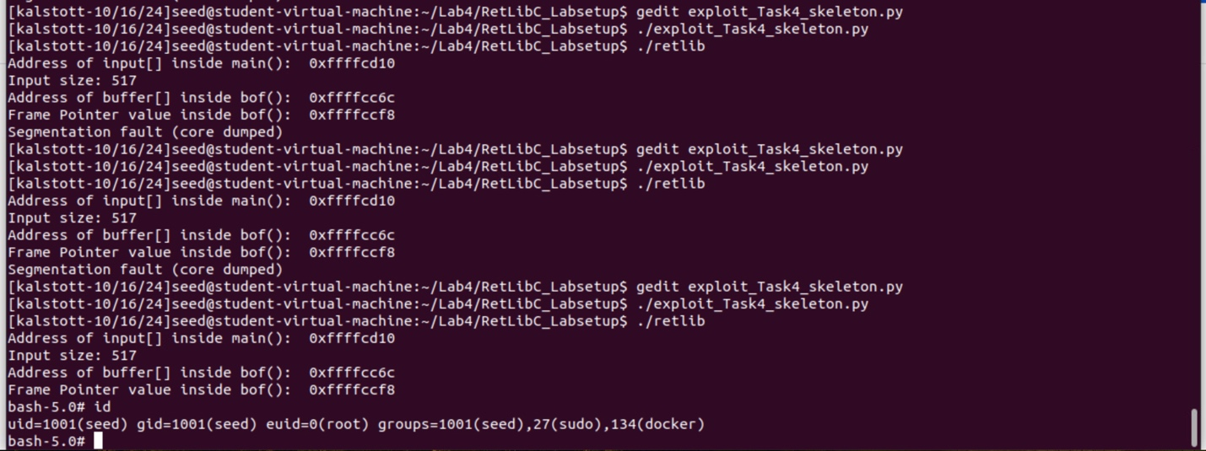

As you can see below, I tried a couple of times testing values that didn’t work till correctly taking an educated guess on 300. Once all the values were set and we run the commands needed for the attack, our attack was successful! Giving us root shell and defeating the countermeasure of bash and dash.

Funny Joke Time

**What did the hacker say after a failed return-to-libc attack?**

"I guess I need to get my bytes together…"

The image below is supposed to say “Segmentation fault” but I ran out of attempts with the new ChatGPT. Got a kick out of what it was producing for this haha.

